**CENTRE FOR RESEARCH IN EMPIRICAL SOCIAL SCIENCES (CRESS)**

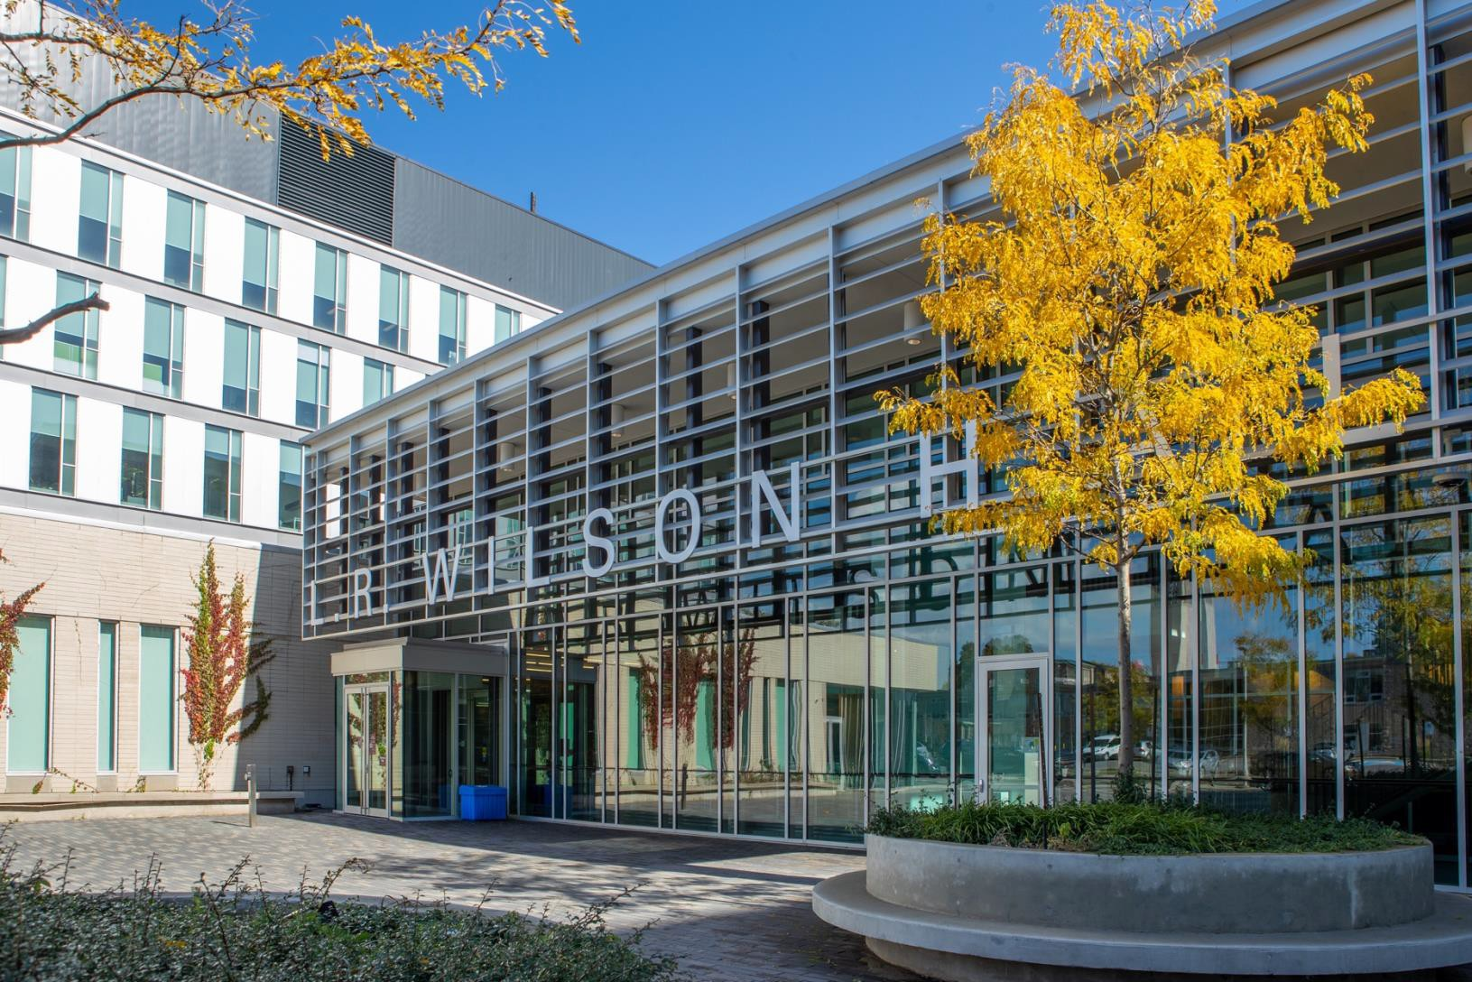

**Annual Report**

**2019-2020**

The Centre for Research in Empirical Social Sciences (CRESS) catalyzes cutting-edge social science research across disciplines.

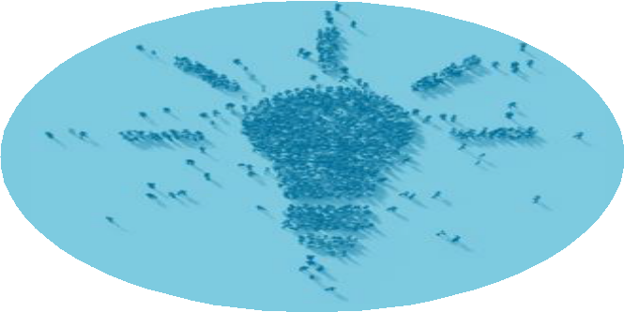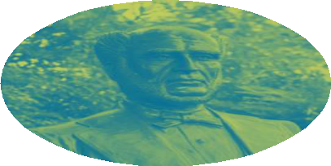

**TABLE OF CONTENTS**

**Centre Overview 3**

**Staffing & Governance 3**

**2019-20 Activities 5**

**Looking Ahead 10**

Through partnerships, training, and

facilities, we help researchers expand their methodological boundaries and

## take on exciting new work.

Centre Overview

Many of today’s most pressing challenges, including population health and aging, diminished confidence in core institutions of democracy, climate change, unequal economic growth, and global security, are fundamentally complex, dynamic, and inter-related, creating both immense opportunity and real challenges for socially relevant research. Interdisciplinarity, dynamic/responsive research designs, cultural responsiveness, transparency, and careful layering of methods that reveal different dimensions of a challenge are all critical to modern, leading-edge social science research.

Advances in digital technologies have sparked proliferation of new data types and sources that require social scientists to develop new methods for analyzing such data and to analyze old data with new methods. Maximizing research opportunities in this context requires both new physical infrastructure and new research networks.

At the same time, recent social movements have highlighted systemic racism not only in society but also in the academy, including the recognition that academic research has done harm when not carefully and thoughtfully addressing issues of positionality and power in its work. BIPOC scholars are calling upon the social science research community to review and reconsider methods and approaches to exploring all social questions, not just those explicitly engaging with communities of colour.

The complexity of the social challenges, the data, and the methods needed to study them means that no one scientist can master all domains.

Officially founded in December 2019, CRESS exists to catalyze innovation in social science research. We do this through teaching and training in advanced methods, direct consultation with researchers, and the development of inter-disciplinary and community research and training partnerships.

# Staffing & Governance

### Centre Leadership & Staff

**Allison A. Van** (BS/BA, University of Washington & MPP, Harvard University), **Executive Director**, joined CRESS in July 2019. Previously, she was the Associate Director of Evaluation at the North Carolina Translational and Clinical Sciences Institute at the University of North Carolina at Chapel Hill. Allison specializes in mixed- methods complex systems analysis, community/academic partnerships, and the translation of research into social change. Her career has traversed sectors and disciplines, including extensive work in agricultural and rural development, poverty, child welfare and juvenile justice, social entrepreneurship, and medical innovation. Uniting these experiences was a common approach to applied research and experimentation, allowing Allison to engage with radically different systems and organizations. She brings to McMaster significant research experience working with community organizations and in program evaluation from her prior experience at Winrock International, the Annie E. Casey Foundation, and the National Rural Funders Collaborative.



*Allison Van, Executive Director*

In February 2020, **Michelle L. Dion** (BA, University of Texas & MA/PhD, University of North Carolina), an Associate Professor of Political Science and the Senator William McMaster Chair in Gender & Methodology, was formally appointed **Academic Director** (2020-2025), after serving informally in this role since 2017. Michelle has a strong record of interdisciplinary research at McMaster, with a focus on public policy, cross-national public opinion, and the sociology of social science.

Michelle’s research draws upon a range of qualitative and quantitative evidence and methodologies to advance our understanding of political and social dynamics. She has over 20 years of experience teaching research design and quantitative methods in the social sciences, including five years as a visiting instructor in the University of Michigan Inter-University Consortium for Social and Political Research (ICPSR) Summer Program, the oldest summer school for quantitative social science.



*Michelle L. Dion, Academic Director*

Since May 2020, **Cheryl Fenn** brings more than 15 years’ experience, her attention to detail, and her enthusiasm for learning and social innovation to the CRESS team in her role as **Office Administrator**. Cheryl comes from a dot com tech background, supporting new start-ups in their early days to help them grow. She has been a part of the growth for eBay, PayPal, Facebook and Instagram.



*Cheryl Fenn, Office Administrator*

In 2019-2020, five students also worked with CRESS to implement our programming and support knowledge mobilization and communication with the McMaster and Hamilton communities. CRESS’s student team is critical to our successes, and we have been honoured to work with such talented and creative students.

### Centre Governance

As a Senate-approved Centre, CRESS reports to its **Governing Board**, which is Chaired by the Dean of the Faculty of Social Sciences, **Dr. Jeremiah Hurley**, who is also Professor and former Chair in Economics.

Other Board Members include: **Dr. James Dunn** (Professor and Chair of Health, Aging & Society and Senator William McMaster Chair in Urban Health Equity), **Dr. Tina Fetner** (Professor and Chair of Sociology), and **Dr. James Gillett** (Associate Professor in Health Aging & Society and Associate Dean Research and Graduate Studies, Social Sciences). Drs. Hurley and Fetner chaired the original working group that developed the core vision for CRESS, and Dr. Dunn was a member.

In 2020-21, as CRESS matures, it will build its **Advisory** and **Steering Committees**, which will provide input regarding CRESS’s scientific and scholarly priorities and strategic directions and programming.

# 2019-20 Activities

### Grant Activities

#### Funded

In June 2019, Dr. Michelle Dion received funding for a SSHRC Connection Grant ($22,794) as part of the Research Data Management Initiative to support the **Transparent Research Workshop Series** (see below).

**YouthCAN**, a Hamilton-based collaboration of over twenty organisations addressing youth unemployment brought CRESS into a grant proposal for the federal Youth Employment Skills Strategy, as the project’s evaluator. The funded project, 360[4]Youth, began in summer 2020 and will bring $147,000 to CRESS over three years.

The **McPherson Centre** at McMaster awarded CRESS a

$2000 Student Partners Program grant to fund a student working with us in summer 2020 on curriculum development.

#### Submitted

In April 2020, CRESS collaborated with the **Sherman Centre for Digital Scholarship** (Faculty of Humanities and McMaster Libraries) to submit a SSHRC Connection Grant application ($28,483) to support the 2020-2021 **Relevant Research** workshop series at McMaster. The series will consist of monthly day-long workshops focused on communicating and developing strategies for effective knowledge mobilization that cross disciplinary boundaries in the Humanities and Social Sciences.

#### In-kind Grant Support

CRESS has also provided approximately $3000 in commitments of in-kind support for SSHRC grant applications led by faculty members in Labour Studies, Economics, and Sociology. Support included space, training, and other research supports.

### Educational Programming and Training

#### Transparent Research Workshop Series

These SSHRC-funded monthly, day-long workshops throughout the academic year provide direct, practical skills and experience to ensure that researchers are prepared to meet expectations for research transparency in accordance with Tri-Council Agency guidelines.

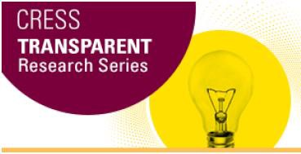

Before disruptions due to the COVID-19 pandemic, CRESS hosted five innovative workshops with leading experts on data transparency practices in the social sciences, including:

* **Research Data Management Plans** with **Maggie Neilson** (Academic Librarian, Acadia University) and **James Doiron** (Research Management Coordinator, University of Alberta), who co-Chair the Data Management Expert Group of Portage Network, which contribute to the shared stewardship of research data and address specific gaps in national research data management infrastructure in Canada. (30 attendees)
* **Transparency Methods for Social Scientists using Python** with **Mickael Temporão**, Head of Data Science, Delphia, a Toronto-based start-up. (16 attendees)
* **Reproducible data analysis in R** with Dr. **Jeffrey S. Racine** (Professor, Economics, McMaster), who has authored a definitive textbook on this topic. (10 attendees)
* **Reproducible data analysis in STATA** with **Dr. J. Scott Long** (Professor, Sociology, Indiana University), author of the definitive guide to reproducible research using STATA. (15 attendees)

#### Transparent Research Workshop Series (continued)

* + **Indigenous Data Sovereignty**, an event hosted in collaboration with the **Indigenous Studies Program** and the **McMaster Institute for Indigenous Research (MIRI).** The event included a panel discussion and workshops with **Dr. Aaron Franks** (Senior Manager, OCAP® & Information Governance, First Nations Information Governance Centre, FNIGC) and **Robin Rowe** (Laurentian University). The panel was moderated by **Dr. Vanessa Watts** (Sociology & Indigenous Studies, McMaster). Afternoon workshops led by Franks & Rowe helped participants think through data sovereignty in practice. (76 attendees)

Overall, **nearly 200 students, faculty, staff and/or community partners** attended our workshops in 2019-

20. The workshop series was partially funded by a SSHRC Connection Grant (Michelle L. Dion, Applicant).

#### Master of Public Policy in Digital Society Proposal Development

CRESS collaborated with faculty members in **Political**

**Science** and **Economics** in their development of a new Master of Public Policy in Digital Society, which was approved in spring 2020.

The **Master of Public Policy in Digital Society** is a professional graduate degree that combines traditional seminar-based learning formats along with skill development labs in order to establish a set of core competencies at the intersection of public policy and digital technology.

This innovative, interdisciplinary degree program will include a number of 1.5-unit skill development labs to complement traditional 3-unit seminar courses.

**Productivity During Pandemic - Speaker Series** As research and learning moved online due to the COVID-19 pandemic, CRESS launched an innovative weekly pilot speaker series to connect researchers, including faculty and graduate students while working from home in the early months of the pandemic.



These one-hour virtual research talks focus on methods and tools of social research, particularly those most relevant for moving research online during the pandemic. Popular topics have included tips for conducting virtual one-on-one interviews and how to promote your research on social media platforms, such as Twitter. Other sessions highlighted scholarship of junior BIPOC scholars across the social sciences.

Before the end of June 2020, we hosted more than 10 virtual speaker events. Videos of these talks are posted on the CRESS MacVideo channel.

#### No Crystal Ball: Decision-making in Uncertain Times video series

The Faculty of Social Sciences **Community Research Platform**, the **Office of Community Engagement**, and CRESS recognized in late 2019 the complementarity in our missions around supporting community-engaged research. We began planning for an Evaluative Thinking workshop series for community organizations.

As the COVID-19 pandemic unfolded in spring 2020, we quickly changed this plan in response to community partner feedback, deciding instead to focus on decision- making, as a narrower aspect of evaluative thinking, and to deliver the content as a video series.

**Allison Van** began development and recording of the ten-part video series, **No Crystal Ball: Decision Making in Uncertain Times** in late spring 2020.



The series combines research on decision-making with the impacts of uncertainty, stress and fear on decision- making processes, offering community organization executives and staff straightforward tools and approaches to strengthening decision-making. The series is scheduled to launch in December 2020.

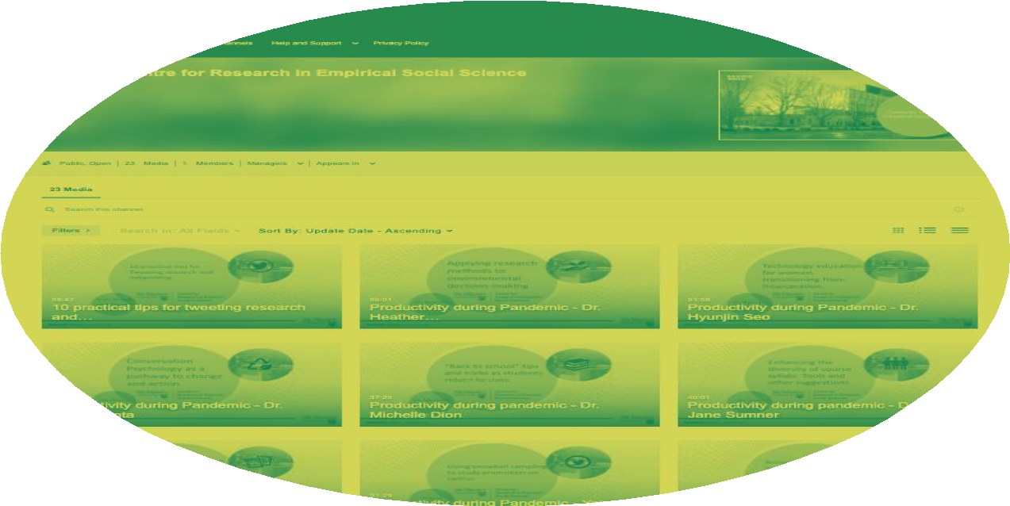

### Support for Research Collaboration

#### Coworking Space

As part of our mission to support interdisciplinary collaboration, we began building a comfortable, stimulating coworking space called the **CRESS CoLab** on the 5th floor of L.R. Wilson Hall that is available to all research teams, faculty, and grad students.

The CRESS CoLab is built on the simple but well- demonstrated principles that innovation often emerges from interdisciplinary partnerships, and interdisciplinary partnerships often emerge from informal conversation between researchers.

In addition, groups within the faculty, such as departments, research groups, common interest groups, etc., can create private spaces in which members can message each other, share files, or jump on a video call together. All individuals and units in the Faculty are invited to organize events for the whole Virtual CoLab community or restricted to certain groups.

The space is meant to accommodate both serious collaboration and learning, and individual support and fun together. It has also become a central hub for posting McMaster university events, academic or other professional opportunities, such as calls for papers, conferences, or other educational opportunities in the social sciences.

Like commercial coworking spaces, CoLab is not just a place to work. CoLab members are invited to participate

in workshops and other community events to promote connections and enhance members’ research.



#### Virtual CoLaboratory Space on Slack

The **Virtual CoLa**b functions as the equivalent of the physical CoLab while the McMaster campus is closed. When the pandemic caused the physical university to close, we recognized that for some the pandemic has created overwhelming family obligations, while others have become isolated. In both cases, a low key, easy online community, supporting (rather than distracting from) learning, teaching and research could help.

CoLab members can have the Slack app open or closed, choose to receive notifications or have them turned off. They can have it on as they’re working, and periodically take a break to chat with another member or post something interesting.

The CoLab is not just a place to work, but also a place to learn & collaborate on interdisciplinary research.

**Other Supports for Interdisciplinary Research** CRESS also supports interdisciplinary research by organizing meetings and other events designed to bring together faculty and graduate students interested in a common social science problem or question. For example, we worked with **Dr. Judy Fudge** (Professor, Labour Studies) to convene migration researchers at McMaster to expand collaboration.

### Other Research Support

#### Research Consultations

At CRESS, we have expertise in a wide array of qualitative and quantitative methods and can help turn research ideas into protocols and research designs.

We not only advise researchers on methods and tools, but direct them to other state-of the-art facilities and equipment in the Faculty of Social Sciences, such as the Secure Empirical Analysis Lab (**SEAL**), experimental lab with virtual reality equipment (**McDSL**), and interview and focus group rooms with advanced video capability (**Qualitative Suite**).

In 2019-20, we provided more than 30 hours of research consultations for **14 faculty and graduate students** in the Faculty of Social Sciences.

#### Applied Research & Evaluation Services

In our first year, we also began piloting and developing the business model for providing applied research and evaluation services to internal and external McMaster partners.

Such services will be essential for supporting innovative social research at McMaster and in collaboration with Hamilton community partners by providing the dedicated support and long-term commitment to address complex social problems with research solutions.

Partnerships between faculty members and community organisations and student efforts through the **Office of Community Engagement** both meet many community needs, but are limited in the commitments they can make, as they rely on voluntary efforts or funding for the collaboration to continue.

CRESS seeks to address this gap by providing rigorous, high quality research and evaluation services at reasonable rates. Led by **Allison Van**, who has twenty years of experience as a respected evaluator in the United States, CRESS staff and students build and implement research designs to meet the specific needs of community organisations.

Our first effort, the evaluation of the **360[4]Youth** program of the **YouthCAN** network in Hamilton, will involve up to five students in advanced mixed methods research under close supervision and support.

Engagement with faculty who have aligned research interests is similarly meant to encourage interdisciplinary creative thinking about applied research designs and protocols.



#### Developing Research Partnerships

Throughout the inaugural year of CRESS, we began supporting interdisciplinary social science research with workshops, creation of collaborative in person and online spaces, and customized research and grant support for researchers in the Faculty of Social Sciences.



Perhaps as important is the work we did to lay the groundwork for future CRESS growth and development of productive collaborations with internal and external stakeholders.

Internally, we worked with individual faculty members to support grant applications and research projects. We also developed working relationships with other McMaster units, such as **Housing and Conference Services**, the **McMaster Institute for Indigenous Research (MIRI), Office of Community Engagement, Research and High-Performance Computing Service (RHPCS)**, **University Technology Service**, **Faculty of Humanities**, the **Libraries**, and the **Sherman Centre for Digital Scholarship**.

We also invited external partners from community organizations and local government to participate in CRESS workshops.

These pilot events or partnerships are invaluable for CRESS as it identifies the scope and landscape of collaborations that will support and advance innovative social research at McMaster.

# Looking Ahead

In 2020-21, CRESS will expand upon our research consultation services, moving from our “soft launch” where knowledge of our services spread by word of mouth, to an “active launch” communicating our availability and expertise to faculty and graduate students. We also intend to re-design our website to better inform researchers of how we can support them and directly share commonly requested resources.

We will expand our educational offerings by piloting a short-course in using statistical software (such as STATA) and designing curricula for the new Master of Public Policy in Digital Society and applied research skill certificates, which will include courses such as Working with Data, Social Systems Modelling, Social Inquiry, and Applying Evidence Day to Day.

Given the realities of COVID-19, building meaningful partnerships with individual faculty and McMaster units will be a challenge, but we are committed to finding creative ways to support the exceptional research occurring within the Faculty of Social Sciences and across the university.